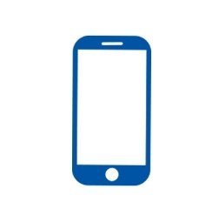

**Connection Between Smart Phone and Controller:**

**Provided By DJI**

**Connection Between Smart Phone and Server:**

**Bluetooth**

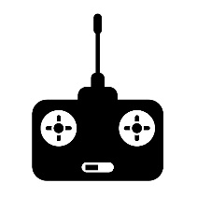

Server

**USB**

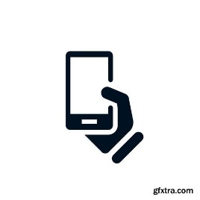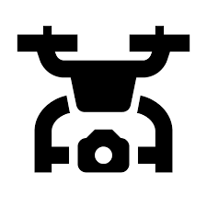

**Send Request**

**Process Request**

**Send User GPS to Controlling Smartphone**

**Drone Deploying**

**Drone Controlling**

**Computer Vision**

**User APP**